ENGINEERING DRAWING - II
20 MCQ’s
- To understand some of the hidden geometry of components an imaginary plane is used to cut the object which is called _____________
a) auxiliary plane b) picture plane c) section plane d) additional plane
- The type of line used to represent the cutting plane in drawing is.
a)
b)
c)
d)

- IN an isometric projection, the included angle between the edges of a cube is ______
a) 30° b) 60° c) 90° d) 120°
- Development of surfaces is used in the development of_______
a) Piping b) Air conditioning duct c) Buckets d) All of the above
- The development of cylinder is a _______ .
a) Rectangle b) Circle c) Ellipse d) None of the above
- The development of lateral surfaces of a pentagonal pyramid is
a) Five squares b) Five rectangles c) Five triangles d) None of the above
- Zone method is used to development of _______
a) Prism b) Pyramid c) Cone d) Sphere
- Which type of lines is part of dimension?
a) Break Lines b) Phantom Lines c) Extension Lines d) Cutting plane Lines
- A drawing instrument set usually contains all the following except ________
a) Bow compass b) Scale c) Dividers d) Extra leads
- The isometric length is _______present of actual length.
a) 65.5 b) 71.5 c) 81.5 d) 91.5

- The primary unit of measurement for engineering drawing and design in the mechanical industries is the ________
a) Millimeter b) Meter c) Kilometer d) Centimeter
- Inclined planes in a three-view drawing will appears________
a) Two surface and one edge b) Three edges
c) One surfaces and two edges d) Foreshortened in each view
- The projection showing in the front in the true shape size is ______
a) Isometric b) Perspective c) Oblique d) Axonometric
14. Orthographic projection represents three-dimensional objects in_______
a) 1-D b) 2-D c) 3-D d) All of the above
- In orthographic projection, the projection lines are __________to the projection plan.
a) Parallel b) Orthogonal c) Inclined d) All of the above
- ________is not a principal view.
a) Bottom b) Side c) Top d) Auxiliary
- The term ortho-graphic ,’Orthos’ means_______
a) Drawing b) Straight c) Projection d) View
- The no of principal view are_______.
a) 2 b) 3 c) 4 d) 6
- In orthographic projection, the object is placed with one of its faces ______to the picture plan
a) Inclined b) Perpendicular c) parallel d) All of the above
- Projection line is _________
a) Continuous thick line b) Continuous thin line c) Chain thin line d) Dashed line

10 Marks Questions
- What is development of surface of cube?.
- Explain isometric projection in detail.
- Describe intersection of surface.
- Describe the isometric drawing and sketching.
- Describe isometric drawing of a rectangle.
- Describe the cylinder and prism..
- Draw the projection of hexagonal pyramid, base 30 mm side and axis 60 mm long, having its base on the H.P. and one of the edges of the base inclined at 45˚ to the V.P..
- Draw the isometric view of fig.
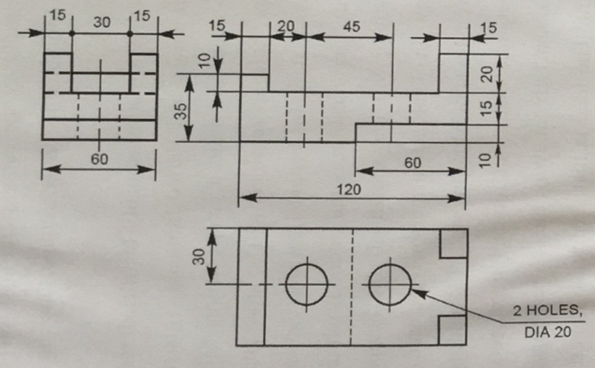

- A pentagonal pyramid, base 30 mm side and axis 65 mm in long has its base horizontal and an edges of the bases parallel to the V.P. a horizontal section plan cuts it at a distance of 25 mm above the base. Draw its from view and sectional top view .
- Develop the lateral surface of the truncated cylinder shown in fig.
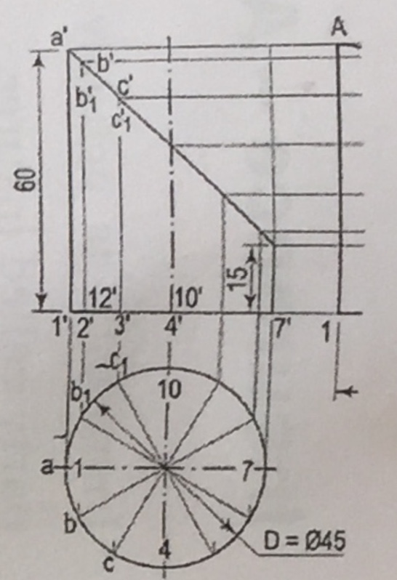
- A vertical square prism, base 50 mm side is completely penetrated by a horizontal square prism, base 35 mm side so that their axis are 6 mm apart. The axis of the horizontal prism is parallel to the V.P. While the face of both prism are equally inclined to the V.P. Draw the projection of the prism showing lines of instruction.
- A vertical cylinder of 75 mm diameter is penetrated by another cylinder of the same size. The axis of the penetrating cylinder is parallel to the both H.P and V.P.is 9 mm away from the axis vertical cylinder. draw the projection showing curves of instruction
- Draw Isometric view .
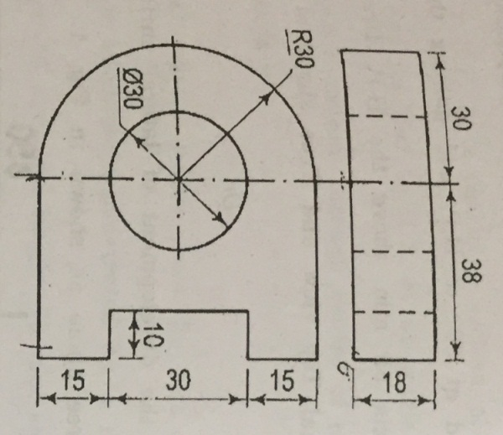
- A square pyramid of base side 25mm and altitude 50mm rests on its base on the HP with two sides of the base parallel to VP. It is cut by a plane bisecting the axis and inclined at 30° to the base. Draw front view, sectional top view and true shape of the section. Also draw the development of the lower part of the pyramid.
- A pentagonal pyramid of 29mm. Edge of base and 60 mm length of axis has a 28mm. Edge on the H.P. The axis is inclined at 35°
5 Marks Questions (Full)
- Explain sketching of sample machine components.
- Explain hexagon and pentagon.
- What is Cylinder?
- Define line instruction.
- Define instruction prism.
- What is cylinder and cone ?
- Explain the hexagon in isometric.
- Explain the surface of cube.
- Explain the section of prism.
- Explain the circle and arc.
- Explain the cylinder pyramid.
- Explain the lines of instruction
- What is the difference between prism and pyramid?
- What is the principal of development of surface?
- 15. Figure 3 shows two views of an object. Draw isometric view of the object.
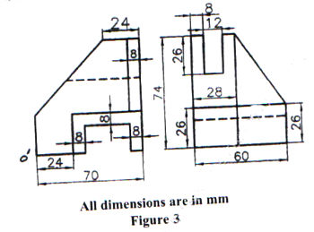
5 Marks Questions (short notes)
- Prism
- Cylinder
- Pyramid
- Isometric drawing of rectangle
- Circle an arc
- Isometric Pentagon
- Surface of cube
- Cone - development of surface
- Instruction of two prism.
- Isometric view of circle
- Line of instruction
- Development of surface-cube

