ENGINEERING DRAWING - I
20 MCQ’s
- The size of the title block is ________ mm x ________ mm.
a) 25 x 10b) 100 x 25c) 65 x 185d) 185 x 65
- Which of the following is reducing scale?
a) 10:1b) 10:2c) 1:5d) 2:1
- The preferred size of the drawing sheets is recommended by the ______
a) B.I.S.b) ASMEc) ASTMd) NIST
- The untrimmed size for _______ sheet is 240 mm x 330 mm.
a) A1b) A3c) A4d) A5
- SP: 46 (2003) recommends the borders of _______ mm width for the sheet sizes A0 and A1, and _______ mm for the sizes A2, A3, A4 and A5.
a) 10, 20b) 15, 20c) 20, 10d) 15, 10
- Which of the following is enlarging scale?
a) 1:1000b) 10:4c) 2:4d) 1:3
- What is the next size of 210 mm x 297 mm in drawing papers?
a) 148 mm x 210 mmb) 297 mm x 420 mm
c) 420 mm x 594 mmd) 105 mm x 148 mm
- Which is the instrument used to draw parallel lines fast?
a) Set squareb) Ruler scalec) Protractord) Roll-n-draw
- The line given below is used for____________
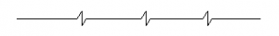
a) Long-break lineb) Cutting planes
c) Centre linesd) Out lines of adjacent parts
- Centre lines, section lines are drawn using __ pencil.
a) Hb) 2Hc) 3H or 4Hd) HB
- The axis of the cylinder or sphere is denoted by which of the following line?
a) Section lineb) Centre linec) Hidden lined) Leader line
- What is the standard length and width of the arrowhead of dimension lines?
a) 2mm and 2mmb) 3mm and 1mmc) 4mm and 2mmd) 3mm and 2mm
- Match the following
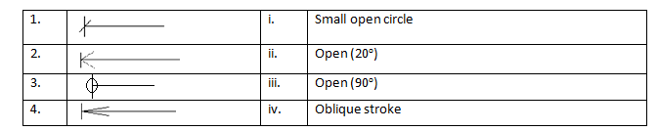
a) 1, i; 2, ii; 3, iii; 4, ivb) 1, ii; 2, iii; 3, i; 4, iv
c) 1, iv; 2, iii; 3, i; 4, iid) 1, iv; 2, i; 3, ii; 4, iii

14. The wrongly represented line in the below figure is _______
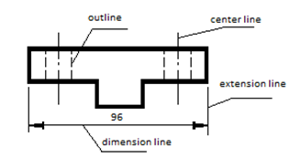
a) dimension lineb) extension linec) outlined) center line
- Representative fraction is the ____________________
a) Ratio of the length in drawing to the actual length
b) Ratio of the actual length to the length in drawing
c) Reciprocal of actual length
d) Square of the length in drawing
- What is the type of scale in which the representative fraction is 1:1?
a) Enlarged scaleb) Reduced scale
c) Full size scaled) Graphical scale
- Which of the following scales represent two different units having the same representative fraction?
a) Plain scaleb) Diagonal scale
c) Comparative scaled) Vernier scale
- In general method of drawing an ellipse, a vertical line called as ____ is drawn first.
a) Tangentb) Normalc) Major axisd) Directrix
- In first angle projection method, the object is lies between observer and ____
a) top viewb) Plane of projections
c) Observerd) front view
- The object is assumed to be kept in the ___quadrant
a) Thirdb) Forthc) Secondd) First

10 Marks Questions
- Explain projection of solid in detail.
- Explain Engineering Drawing ? With layout drawing sheet.
- Explain orthographic projection in detail.
- Explain methods and construction of various types of curves in detail.
- What is Engineering Drawing?
- Construct a scale 1.5 inches = 1foot to show inches long enough long to measure upto 4 foot.
- Explain different types of scales used in the engineering Drawing.
- Explain different types of sheet size and their uses.
- Draw an involute of square of 36 mm side.
- Draw front view, top view and side view using first angle method
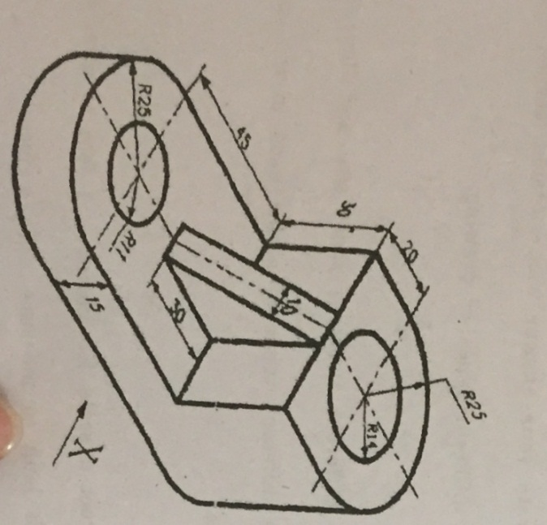

- Draw a projection of a regular hexagon of 25 mm side having one of its sides in the H.P. and inclined at 60°. The V.P. and its surface making an angle of 45° with the H.P.
- Construct an ellipse by arc of circle method using 120 mm major axis and 72 mm minor axis.
- An equilateral triangle of 50 mm side has its V.T. parallel to and 25 mm above xy. It has no H.T. Draw its projection when one of its side is inclined at 45° to the V.P.
- Draw a rectangle having its sides 125 mm long and 75 mm long . Inscribe two parabolas of it with their axes bisecting each other.
- A pictorial view of the object. Draw front view, top view and right hand side view using thired angle method.
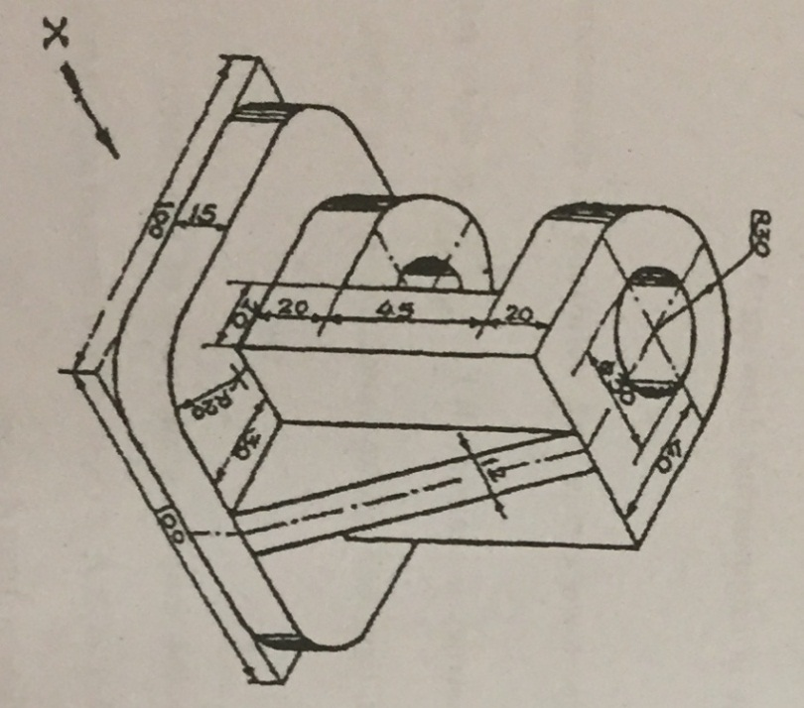

16.The pictorial view of a machine part is shown in following figure. Draw
1) Front view from2) Top view3) Insert at least 6 Dimensions.
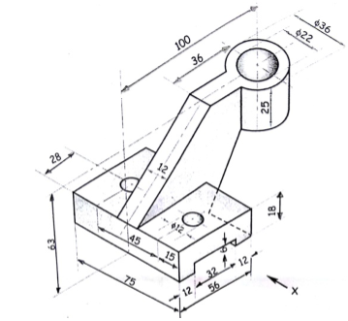

5 Marks Questions (Full)
- Write down types of scales
- What is drawing sheet?
- What is vernier scale?
- What is sketch?
- Explain types of lines.
- What is R.F.?.
- Explain Types of scales.
- Explain dimension systems.
- What are the different types of machine drawings?
- Write down types of curves.
- Difference between first angle method and Third angle method.
- Explain first angle method.
- Explain Third angle method.
- Write down Types of solids.
- Write down Types of Planes.

5 Marks Questions (short notes)
- Lettering
- Types of Scales
- Third angle projection
- Dimensioning
- Single stroke letters
- Gothic letters
- Free hand sketch
- Drawing Sheet
- R.F.
- Types of lines
- Types of curves
- Tittle Block

